

**Faculty of engineering - Shoubra**

**Benha University**

**Research Article / Research Project / Literature Review**

in fulfillment of the requirements of

|  |  |
| --- | --- |
| **Department** | **Engineering Mathematics and Physics** |
| **Division** | **-----------** |
| **Academic Year** | **2019-2020 Preparatory** |
| **Course name** | **Computer** |
| **Course code** | **ECE001** |

**Title: -**

**Computer Engineering Role in COVID-19 Pandemic**

By:

|  |  |  |  |
| --- | --- | --- | --- |
|  | Name | Edu mail | B.N |
| 1 | احمد جلال محمد رفاعى | ahmed195038@feng.bu.edu.eg | 37 |

**Approved by:**

|  |  |
| --- | --- |
| Examiners committee | Signature |
| Dr.Ahmed Bayoumi |  |
| Dr.Shady Elmashad |  |
| Dr. Abdelhamid Attaby |  |

**Git-Hub Link:**

**Git-Hub Pages(published-website):**

<https://ahmedg147.github.io/html-project-Repository/>

**Brief of** **Computer Engineering Role in COVID-19 Pandemic:**

The 2019 coronavirus disease (COVID-19) pandemic has exposed a number of weaknesses in health-care systems around the world and in the global economy. In a new editorial a team of engineers and computer scientists suggests that the present pandemic moment will serve as a wake-up call to accept the possibilities of robotics in society and the public health environment.

The publishing house, which appeared in Science Robotics, was published by the founding editor of the journal, Guang-Zhong Yang, PhD, and colleagues from around the world. Yang is a professor and dean of the Shanghai Jiao Tong University Medical Robotics Institute, China. In the article, Yang and his co-authors wrote that while occasional attention to the potential role of robotics in public health emergencies, little has been done to turn the vast potential into practice.

The editorial describes a long list of places where robots may assist in or take over the health care professionals' job. "Robots have the ability to clean, distribute medications and food, assess vital signs, and assist border controls," they wrote

**Screenshots of the report:**

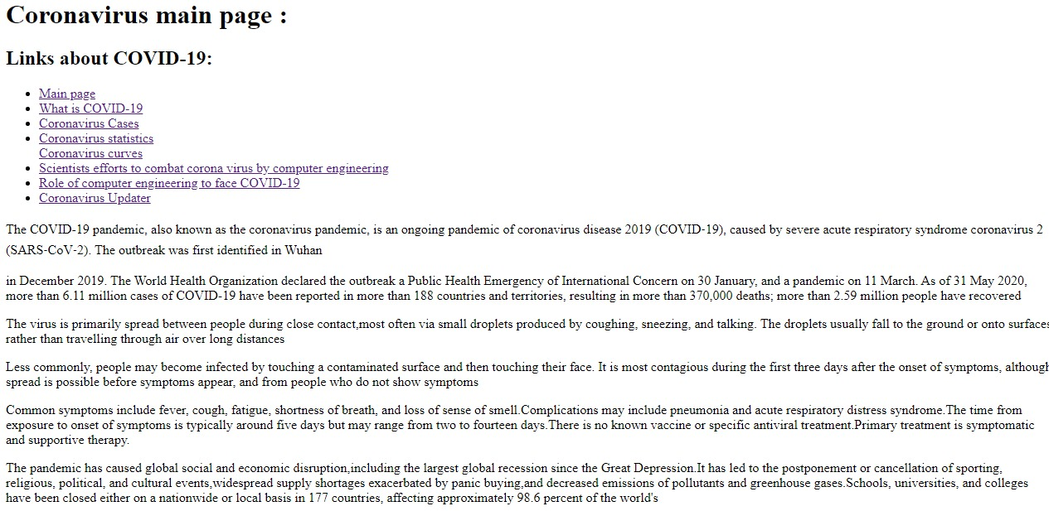

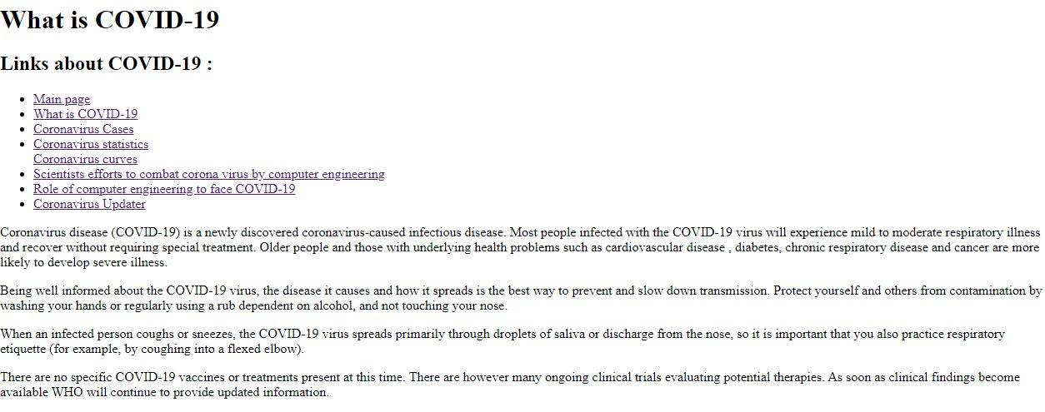

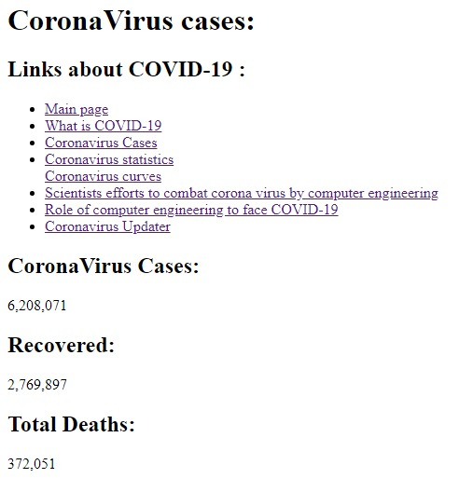

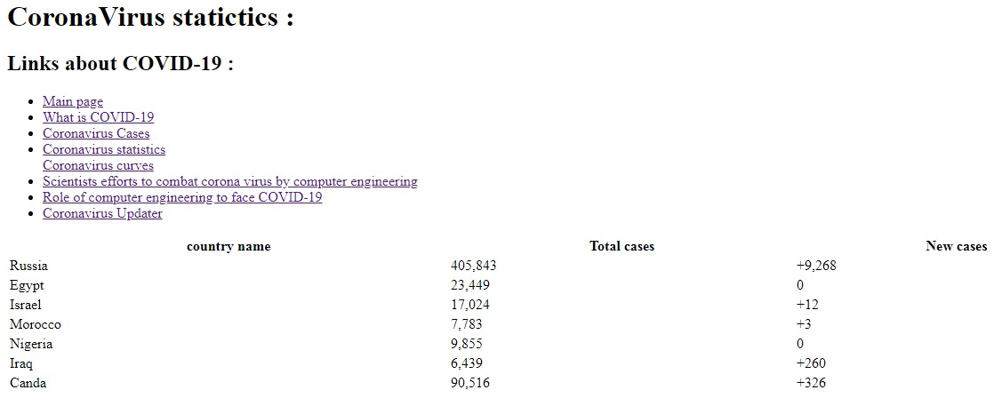

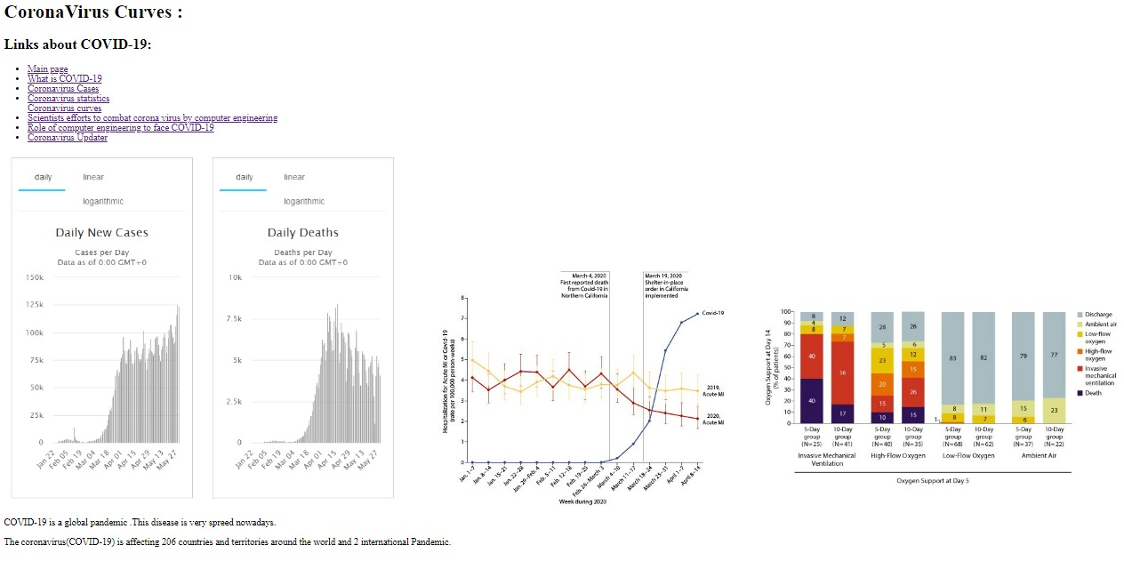

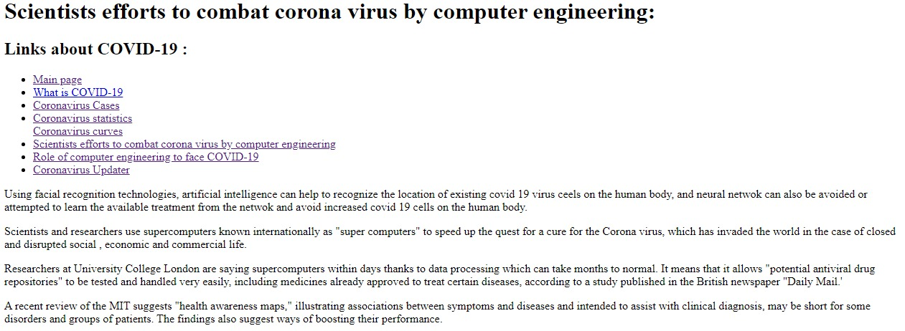

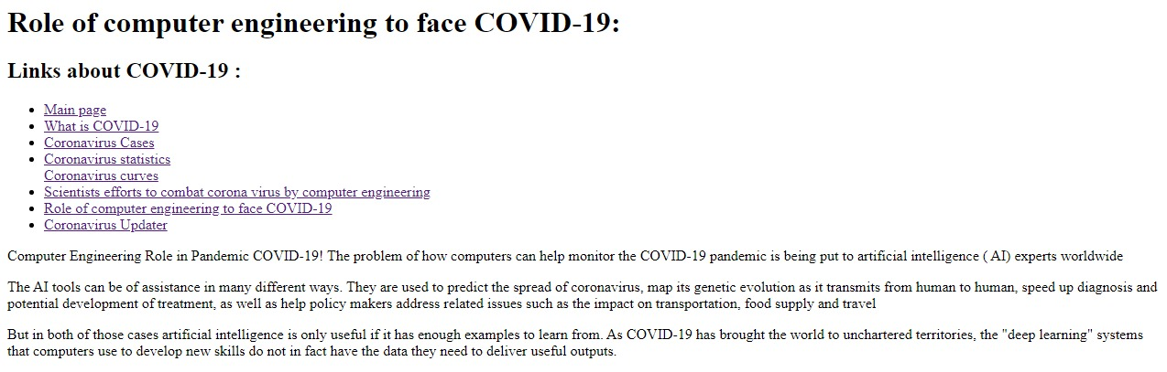

**Source code:**



